**Final Year Research Topic**

**Vulnerability Tracker**

There is government compliance to scan the servers so currently it is scanned manually those tasks are automated by this system. In this system, the servers’ vulnerabilities will be fixed by assigning them to the relevant person in the organization. When it is fixed by the assigned user it will be forwarded to the department that assigned the task. That department will be checked if it is fixed by scanning the server then the status will be updated as the vulnerability is fixed if it is still not fixed the status will be not updated. There are some scenarios the assigned user will reject the assigned tasks since it is not related to them. So, tasks must be assigned to a related user again by that assigning department.

### **Maintain the Server details with the priority level**

#### Include the live server details on a priority basis.

#### Include the vulnerability scanning schedule according to the priority basis of the servers.

#### Include tags related to server details (Ex:- O/S version, Web application, Service)

#### Include scan details, follow-up details, and escalation details.

#### The system shall allow browsing on a particular server and viewing the details.

#### The system shall display detailed information about the on boarded server.

### **Manage server details (Add/Remove/Update)**

#### The system shall allow adding/removing/updating server details on a user basis.

#### The system shall allow adding vulnerability scan details on the following categories App

DB, O/S

# The system shall allow to update of the Vulnerability status after fixing by the responsible party.

### **Provide a Search facility.**

# The system shall enable the user to search for particular server details by providing a keyword.

# The system shall enable users to select multiple options on the screen to search.

# The system shall display all the matching products based on the search.

# The system shall enable the user to navigate between the search results.

# The system shall notify the user when no matching product is found on the search.

### **Maintain user profiles**

# The system shall allow the user to create a profile and set his credential.

# The system shall authenticate user credentials to view the profile.

# The system shall all the ow user to update their profile information.

# The system shall allow the user to commit the fixed vulnerability from the system.

# The system shall display assigned vulnerabilities of the particular servers to the users.

### **Provide personalized profile**

### .

1. The system shall display V/A scan history in the user profile.
2. The system shall allow users to assign vulnerabilities to particular business units.
3. The system shall display detailed information about the selected server.
4. The system shall allow to over-right of committed tasks of a particular user by the admin account.

### **Email confirmation**

1. The system shall maintain the user’s email information as a required part of the customer profile.
2. The system shall send an email to the respective user when a particular vulnerability was assigned.
3. The system shall send follow-up emails to the users based on the assigned vulnerabilities.
4. The system shall escalate the follow-up to the next line of command when the first two follow-ups didn’t get any reply.
5. The system shall display all the follow-up details.

### **Report Generation**

1. The system shall display customized reports based on the imputed content.

**Sub components**

Servers/Users on boarding

Generate Scan

Accept/Complete Job

Reject - Reassign

Re scanning

Scan Summary

Dependency Approval

**ER Diagram**

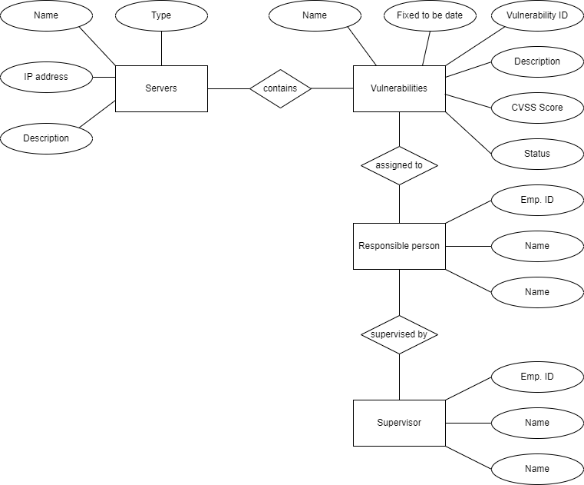

**Related Research Papers**

<https://www.cbsl.gov.lk/sites/default/files/cbslweb_documents/laws/cdg/Banking_Act_Directions_No_16_of_2021.pdf>

<https://link.springer.com/article/10.1007/s42979-022-01271-1>

<https://www.sciencedirect.com/science/article/pii/S1877050917304568>

<https://ieeexplore.ieee.org/document/8997964>

**Loyalty Points Exchange System**

The loyal cards are the same for all companies. User can register their loyalty card for any registered company. Users can access the app we developed to check the available loyalty points, and discounts available in the company. The novelty of the system is that if users forgot to bring their loyalty cards user can use the mobile application, we developed to generate the QR code, so the company can scan it from the web application to redeem the points of the user. Companies can retrieve the user points by scanning the card or QR code. All the users are managed using block chain and cloud technology. Users and companies have 2 different portals to authenticate and login to the system.

### **Maintain the user profile**

1. The system will allow the user to create a profile and set his credential.
2. The system will allow the user to reset their passwords.
3. The system will allow them to update their profile details.
4. Display the points, balance, points used and total point.
5. Change the password or reset the password.

**Provide some details**

1. About the companies. (especially discounts, seasonal offers, and raffle draws)
2. Gifts and Gift Vouchers for the loyalty points.

**Manage loyalty points**

1. Add loyalty points.
2. Deduct the loyalty points.
3. Calculate the balance loyalty points.

**Sub components**

QR Code generator

Loyalty points manager

User Management

Vendor Management

User authentication system

**ER Diagram**

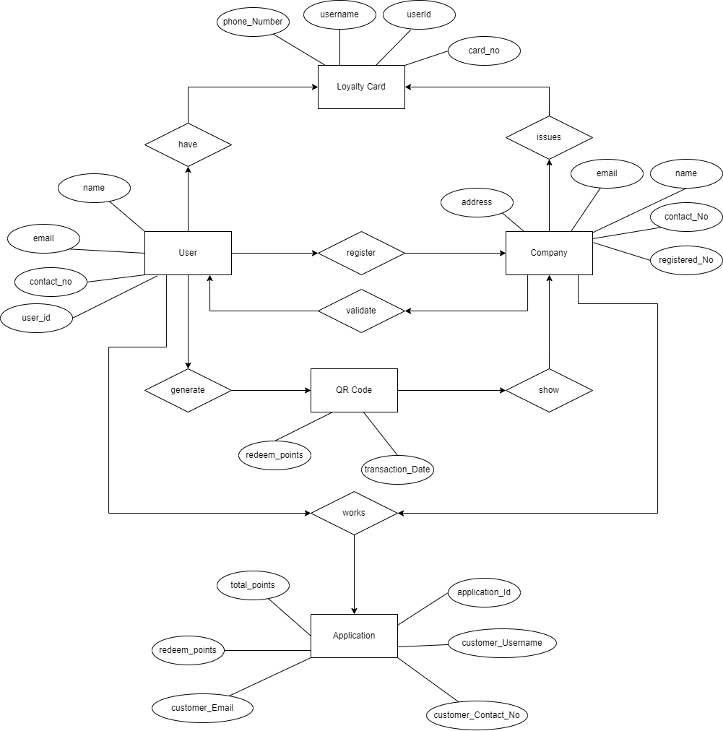

D

**Related Research Papers**

<https://ieeexplore.ieee.org/document/9284795>

<https://www.cambridge.org/core/journals/knowledge-engineering-review/article/abs/loyalty-program-based-on-waves-blockchain-and-mobile-phone-interactions/5C501BA2BE5B8D296B1498792C080843>

<https://ieeexplore.ieee.org/document/9417501>